Training Programme for Spiritual Directors
Aylesford Tutors

Angela Black: Course Director and Tutor
Following a career as a physiotherapist in the NHS, Angela trained as a Spiritual Director at the Franciscan International Study Centre in 2015. Building on her experience in spiritual direction, she trained as a supervisor to support others offering spiritual direction. She currently offers spiritual direction and provides supervision.
Angela has an MA in Christian Spirituality.

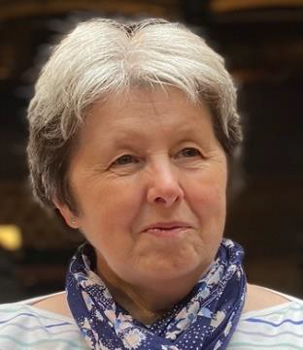

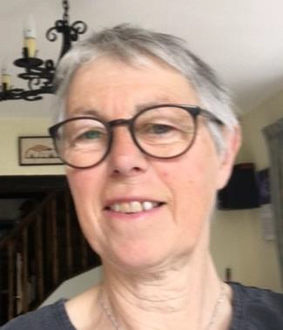
Marie Mann: Course Tutor
After an early career as an Architect, Marie completed a diploma in Spirituality and Psychology at St Anselm, Cliftonville, then trained in 2004 as a Spiritual Director at the Franciscan International Study Centre. She continued to work at the Franciscan Centre training Spiritual Directors, a role she continued with whilst working as Faith Formation Advisor for Southwark Archdiocese. Marie has an MA in Leadership in Catholic Education and was previously course director.

Visiting Lecturers
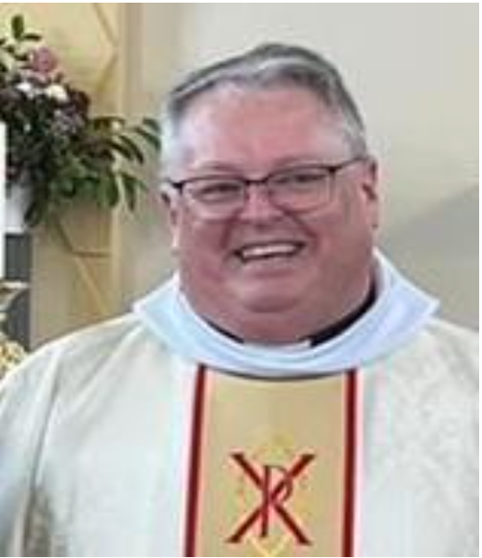
Canon Luke Smith: studied for the priesthood at St John's Seminary Wonersh and was ordained priest for the Archdiocese of Southwark in 1995; serving in the parishes of Addiscombe, Sevenoaks, Margate with Cliftonville and Maidstone. In 2017 he was appointed Spiritual Director at St John's Seminary Wonersh and following its recent closure he was appointed as Episcopal Vicar for Priestly Life and Director of Ongoing Formation of Clergy. He holds an honours degree in Theology and an MA in Christian Spirituality; he has been involved in spiritual direction for much of his priestly life and has been called upon to lead various retreats and Days of Recollection.

Louise Carter is an active member of the Hythe, Kent RC parish and Mission Formation Director for L'Arche UK - which comprises 11 faith communities where people with and without learning disabilities share life together.
Louise also works with faith-based ecumenical groups and Roman Catholic clergy and laity in deaneries and parishes in the areas of leadership in a faith context, discernment and organisational development. She is a practicing spiritual director and also accompanies those working in a faith context on an individual basis to support their wellbeing and practice through reflection on their vocation and ministry.
Louise’s work is underpinned by various studies including an MA in Pastoral Studies from Heythrop College, University of London, studies at the Kinharvie Institute, Glasgow, the Gestalt Centre, London, the Franciscan Ecumenical Spiritual Direction training course and St Beuno’s Jesuit Spirituality Centre, North Wales.
Married with 2 grandchildren, she is an enthusiastic (if slightly dodgy!) alto in the Kent University Choral Society, Canterbury.

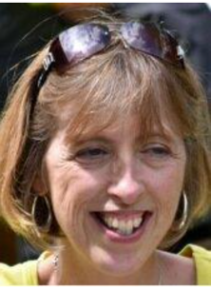

Visiting Facilitators

During each course, we are very pleased to be able to welcome back past students who attend and work alongside the tutors particularly to facilitate the triads. The course is enriched by their input and feedback both as observers in the triads and also through their willingness to share their own knowledge and experiences with the group.

